**A Retrospective Feedback Analysis of Objective Structured Clinical Examination Performance of Undergraduate Medical Students**

Akram Alsahafi 1,2 ; Micheál, Newell1; Thomas Kropmans,1

# **Figures document**

**Figure 1: R Code Implementation: Initial Data Loading Step**

**Figure 2: R Code Implementation: Document Import and Inspection Step**

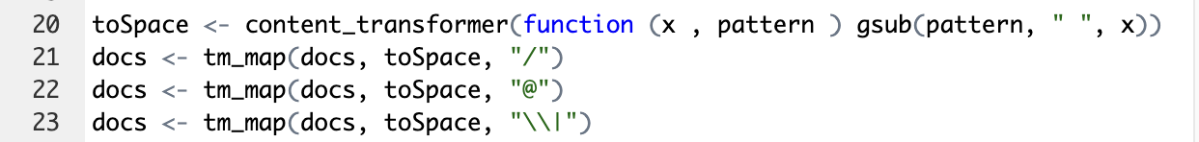

**Figure 3: R Code Implementation: Text Transformation and Special Characters Removal Step**

**Figure 4: R Code Implementation: Text Cleaning - Removing Unnecessary Spaces, Numbers, and Converting to Lowercase**

**Figure 5: R Code Implementation: Term Document Matrix Creation for Word Frequency Analysis**

**Figure 7: Top 200 scoring words cloud in year 1 Figure 8: Top 200 scoring words cloud in year 2**

###### **Figure 9: Top 200 scoring words cloud in year 3 Figure 10: Top 200 scoring words cloud in year 4**

**Figure 11: Top 200 scoring words cloud in year 5**

**Figures 7-11:** Word clouds using the top 200 scoring words from each year in OSCE written feedback showing word importance (word frequency increases as font size increases). Over the five years, "good" is the most frequent used response.